**Information System Management Lab**

**BCOM 307**

**Assignment #3**

***Submitted by:***

**Name:** YASH JAIN

**Enrollment No:** 03914788818

**Semester:** 5th Sem

**Class:** B.Com(H)

**Section**: BCom 5A

**Date of Submission**: 10/09/2021

***Submitted to:***

**Praveen Kumar Singh**

**Assistant Professor, MAIMS**



**Department of Commerce**

**Maharaja Agrasen Institute of Management Studies**

**Affiliated to Guru Gobind Singh Indraprastha University, Delhi**

**Sector -22, Rohini, Delhi -110086, India; www.maims.ac.in**

Maharaja Agrasen Institute of Management Studies

Affiliated to GGS IP University; Recognized u/s 2(f) of UGC Recognized by Bar Council ofIndia; ISO 9001: 2015

Certified Institution Sector 22, Rohini, Delhi -110086, India; [www.maims.ac.in](http://www.maims.ac.in/)

Department of Commerce

Academic Year: 2020-21

Semester: Vth

# Assignment No.3

# Unit No: 1

**Course/Subject Code:** BCOM 307 **Subject Title: Information System Management Lab**

# Issue Date: Last Date of Submission:

**Instructions for Students:**

# All Questions are Compulsory.

1. The student should attach proper cover page for each assignment clearly mentioning the Assignment No.
2. Each assignment should be prepared by the student individually with proper explaination and screenshots.
3. A4 size ruled sheets should be used for the assignment.
4. Assignment pages should be serially numbered at the bottom of page.

***During online education mode, upload scanned copy of the complete assignment including cover page latest by due date.***

|  |  |  |
| --- | --- | --- |
| **Question No.** | **Question** | **CO No.** |
| 1 | Display all the records from client_master table who belong to Delhi and baldue is less than 5000. | **CO1** |
| 2 | Display all the records from client_master table where city is Delhi or Noida. |
| 3 | Display all the records from client_master table where state is ‘Uttar Pradesh’ and city must be Noida or Ghaziabad. |
| 4 | Display all the records from client_master table who don’t belong to Delhi. |
| 5 | Display distinct city values from client_master table. |
| 6 | Delete all the records from Persons table who belong to Delhi. |

**ASSIGNMENT 3 - BASIC TABLE COMMANDS III**

**Task 1 : Display all the records from client_master table who belong to Delhi and baldue is less than 5000.**

The following task is completed using the **‘select’** command with the **‘where’** clause, along with the **‘and’** keyword. The ‘and’ operator allows us to display values where multiple conditions need to be satisfied. The syntax for this is:

select col1,col2,. . . colx from tablename where [condition 1] and [condition 2];(for specific columns)

select * from tablename where [condition 1] and [condition 2];(for all records)

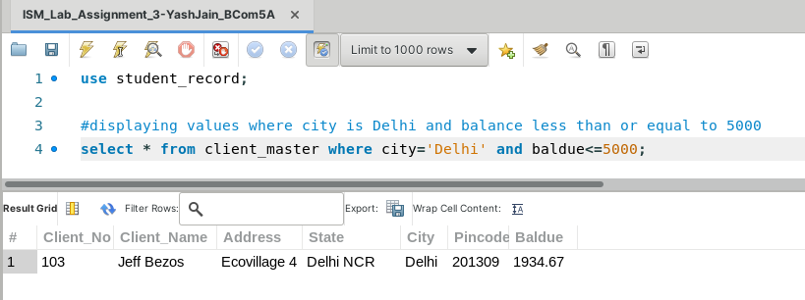

**Task 2: Display the records from client_master where city is Delhi or Noida.**

The given task can be completed using the **‘select’** command with the **‘where’** clause along with the **‘or’** keyword. The ‘or’ operation allows us to display records where the records will be selected even if one of the conditions is met. The syntax for this is:

select col1,col2,. . . colx from tablename where [condition 1] or [condition 2];(for specific columns)

select * from tablename where [condition 1] or [condition 2];(for all records)

Note: The square brackets for the ‘and’ and ‘or’ keywords are not included in the syntax; they are just a way of making it understandable.

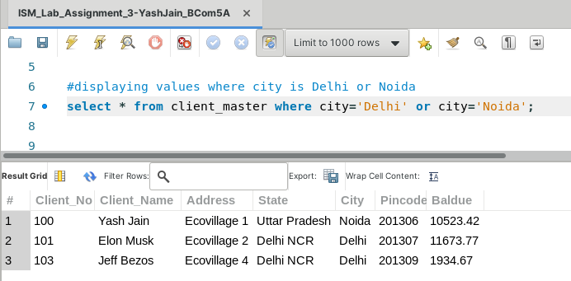

**Task 3: Display all the records from client_master table where state is ‘Uttar Pradesh’ and city must be Noida or Ghaziabad.**

This task can be completed by using the command **‘select’**, along with the **‘where’** clause and this time, we will be using both **‘and’** and **‘or’**. The syntax for this would be:

select col1,col2,. . . colx from tablename where [‘and’ condition 1] and [‘and’ condition 2 / ‘or’ condition 1] or [‘or’ condition 2];(for specific columns)

select * from tablename where [‘and’ condition 1] and [‘and’ condition 2 / ‘or’ condition 1] or [‘or’ condition 2];(for all records)

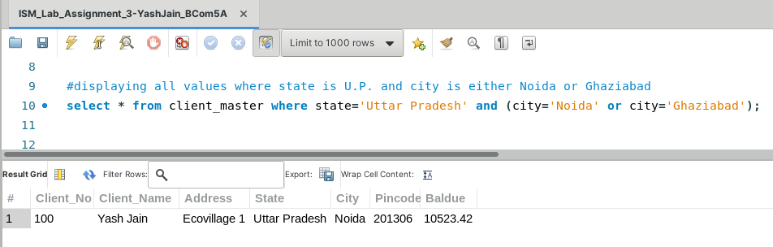

**Task 4: Display all the records from client_master table who don’t belong to Delhi.**

This task can be completed by using the command **‘select’**, with the **‘where’** clause. But, in this case, our condition is inequality, not equality. Hence, we will use an exclamation mark (!) in front of the equal to (=) sign, to indicate the inequality condition. The syntax for this is:

select col1,col2,...colx from tablename where columnname!=’value’; (for specific columns)

select * from tablename where columname!=’value’; (for all records)

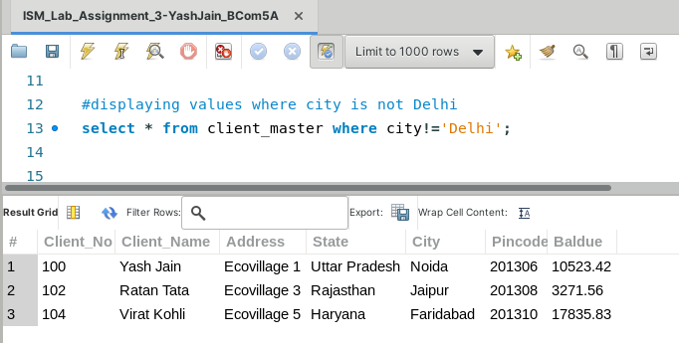

**Task 5: Display distinct city values from client_master table**

To complete this task, we use the **‘distinct’** clause along with the column names after the **‘select’** command, along with ‘where’ clause (optional). The ‘distinct’ clause is used to display all the unique / distinct value in the table, ignoring the duplicate values. The syntax for this is -

select distinct columnname from tablename; (general)

select distinct columnname from tablename where [condition] ;

(for additional conditions)

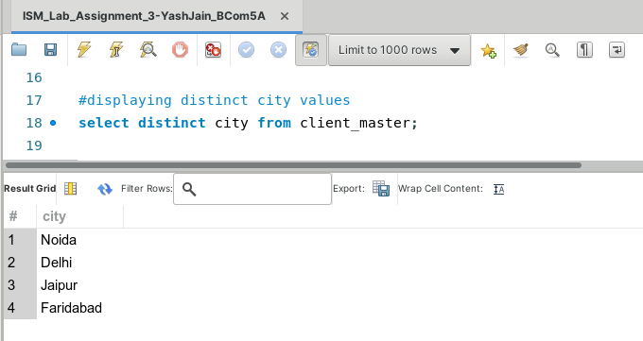

**Task 6: Delete all records from Persons table who belong to Delhi**

To complete this task, we use the **‘delete’** keyword. The ‘delete’ keyword is used to delete rows from a table where a certain condition is given using the ‘where’ clause. The syntax for this is -

delete from tablename where columname=’value’; (for specific records)

delete from tablename; (for all records)

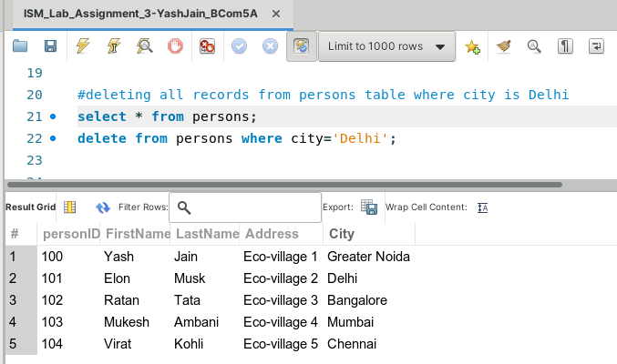

(before deletion)

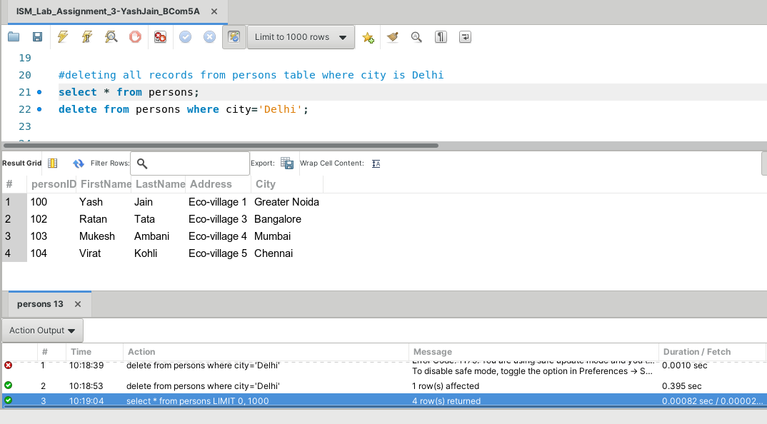

(after deletion)